# Planning and Scheduling: PERT Chart for LinguaEase

## Steps:

1. Research and Planning (2 weeks): Conduct market research, analyze competitor apps, gather user requirements. Predecessor: None.

2. Requirement Specification (1 week): Define functional and non-functional requirements. Predecessor: Research and Planning.

3. UI/UX Design (2 weeks): Design user-friendly interfaces for various features. Predecessor: Requirement Specification.

4. Backend Development (1 weeks): Set up database, API, and server-side logic. Predecessor: Requirement Specification.

5. Frontend Development (1 weeks): Develop the app's user interface based on UI/UX designs. Predecessor: UI/UX Design.

6. Integration (2 weeks): Integrate front-end with back-end functionalities. Predecessor: Backend Development, Frontend Development.

7. Testing (2 weeks): Perform unit testing, system testing, and user acceptance testing. Predecessor: Integration.

8. Deployment (1 week): Deploy the app to app stores and cloud services. Predecessor: Testing.

9. Maintenance and Updates (Ongoing): Monitor app performance, resolve bugs, and release updates. Predecessor: Deployment.

S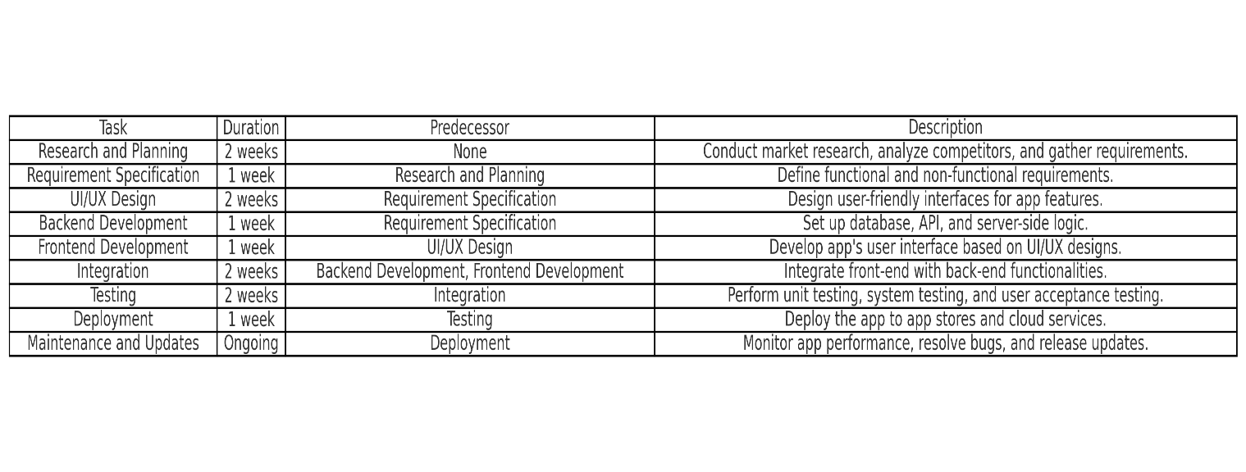

# Event Table for LinguaEase

|  |  |  |  |  |
| --- | --- | --- | --- | --- |
| Event | Trigger | Input | Process | Output |
| User registration | User opens the app | Email, password, profile info | Validate input, save to DB | Confirmation message |
| Login | User submits credentials | Email, password | Authenticate user | Access to dashboard |
| Course selection | User chooses a course | Course preference | Fetch course details | Course overview |
| Lesson completion | User finishes a lesson | Lesson data | Update progress, award points | Progress dashboard |
| Quiz attempt | User starts a quiz | Quiz answers | Evaluate, calculate score | Results and feedback |
| Feedback submission | User submits feedback | Feedback text | Save feedback to DB | Thank you message |

# Use Case Diagram for LinguaEase

## Actors:

1. User: Interacts with the app to learn languages.

2. Admin: Manages courses, tracks user feedback, and monitors system performance.

## Use Cases:

1. Register/Login

2. Select Course

3. Access Lessons

4. Attempt Quizzes

5. Track Progress

6. Submit Feedback

7. Manage Courses (Admin)

8. Monitor App Performance (Admin)

## Diagram:

